Statement on Methods of Assessment in the Mathematical Sciences

Over the last 18 months university departments of mathematical sciences have needed to substantially adapt their learning, teaching, assessment and support practices to respond to the challenges of delivering programmes of study during the Covid-19 pandemic. As learned societies with responsibility for championing the mathematical sciences and supporting those colleagues working within them, we have noted that the transition to online assessment has posed particular challenges.

The transition to online, and therefore, open-book assessment, has been a necessity, but its almost universal use has highlighted particular pedagogical concerns. Such concerns relate to the nature of the material that can reliably be assessed, and how assessments can best be structured to enable students to successfully demonstrate their own knowledge, understanding and application. Most significantly, its use has highlighted concerns in many institutions relating to academic integrity and whether the work submitted by any one student is indeed their own. Such concerns have not only been expressed by academic members of staff, but also by the students themselves. The assurance of academic integrity forms a necessary part of the programme accreditation by both the RSS and IMA.

Whilst the majority of students will honestly and fairly complete their assessments, the now widespread availability of so-called ‘assessment support sites’, means full written answers to posted-questions can be obtained in well under an hour. This is resulting in a noticeable increase in cases of purported ‘contract cheating’ where the assessments of a student are completed by someone else. This practice is not only deeply concerning, but widens inequalities as only those possessing the necessary financial resources or backgrounds can take advantage. Additionally, in an online assessment environment, long-standing concerns in relation to opportunities for collusion amongst students will continue to exist; this must also be carefully considered by institutions.

As learned societies we do not believe it is our role to dictate how university departments of mathematical sciences assess their learners, and we continue to encourage innovation in authentic assessment practices. However, we are gravely concerned to hear of the increasing number of institutions who are indicating their intention to remove, either partially or entirely, the ability for university-level assessments to include proctored on-campus examinations and closed-book assessments. Assessment tasks should be fit for purpose and fair, allowing learning outcomes to be appropriately assessed and ensuring learners are given equitable opportunities to demonstrate their own knowledge and understanding. As in other technical subjects, there are specific bodies of knowledge that students are expected to know and understand; examinations afford the ability to test this in a fair and reliable way.

We therefore ask all universities to support their individual departments, where the academic expertise and experience relating to disciplinary learning and teaching resides, in ensuring they continue to have unrestricted access to the full range of assessment methodologies and techniques that are pedagogically most appropriate to each discipline.

Released by:
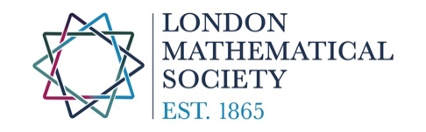
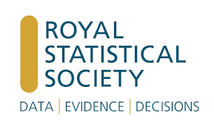
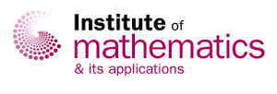

And Endorsed by:
